95% CI’s for Gamma (age at which mortality hazard first reaches 2/3)
and M (maximum age at death)
 | Male |  |  |  | Female
 | Gamma |  | M |  | Gamma |  | M
Cohort | Lower 95% CI | Upper 95% CI | Lower 95% CI | Upper 95% CI | Lower 95% CI | Upper 95% CI | Lower 95% CI | Upper 95% CI
1900 | 104.1 | 105.1 | 109.0 | 116.5 | 106.6 | 109.0 | 112.6 | 120.3
1910 | 105.6 | 106.5 | 111.2 | 118.7 | 109.0 | 111.5 | 115.9 | 123.6
1920 | 105.6 | 106.5 | 112.1 | 119.6 | 109.6 | 111.9 | 117.6 | 125.3
1930 | 109.0 | 110.0 | 115.7 | 123.2 | 112.5 | 115.0 | 121.0 | 128.8
1940 | 112.1 | 113.4 | 118.9 | 126.5 | 116.6 | 119.7 | 125.0 | 132.9
1950 | 115.8 | 117.5 | 122.8 | 130.4 | 120.1 | 123.8 | 128.8 | 137.0
1960 | 116.9 | 119.0 | 123.9 | 131.5 | 125.0 | 130.9 | 132.9 | 141.8
1970 | 117.4 | 120.1 | 125.1 | 132.9 | 128.5 | 136.5 | 136.6 | 146.6
95% CI’s for the change in remaining life expectancy at age 50
relative to cohort born 10 years earlier (years)
 | Due to postponement |  |  |  |  |  | Due to compression
 | Male |  |  | Female |  |  | Male |  |  | Female
Cohort | Lower 95% CI | Median | Upper 95% CI | Lower 95% CI | Median | Upper 95% CI | Lower 95% CI | Median | Upper 95% CI | Lower 95% CI | Median | Upper 95% CI
1900 | -0.1 | 0.0 | 0.1 | 0.1 | 0.2 | 0.4 | 0.7 | 0.8 | 1.0 | 0.7 | 0.9 | 1.2
1910 | 0.3 | 0.4 | 0.5 | 0.7 | 0.8 | 1.0 | 1.8 | 2.0 | 2.1 | 2.2 | 2.5 | 2.7
1920 | -0.1 | 0.0 | 0.1 | 0.1 | 0.2 | 0.4 | 2.3 | 2.4 | 2.6 | 2.6 | 2.8 | 3.0
1930 | 1.0 | 1.1 | 1.2 | 1.0 | 1.2 | 1.4 | -0.1 | 0.1 | 0.2 | 1.3 | 1.5 | 1.7
1940 | 1.0 | 1.1 | 1.3 | 1.6 | 1.9 | 2.3 | 1.5 | 1.6 | 1.8 | 0.8 | 1.0 | 1.3
1950 | 1.1 | 1.4 | 1.6 | 1.1 | 1.7 | 2.2 | 0.4 | 0.5 | 0.7 | 0.4 | 0.6 | 0.8
1960 | 0.2 | 0.5 | 0.8 | 1.6 | 2.5 | 3.5 | 1.6 | 1.8 | 1.9 | 0.5 | 0.8 | 1.1
1970 | -0.1 | 0.3 | 0.7 | 0.9 | 2.0 | 3.3 | 1.1 | 1.4 | 1.8 | 0.8 | 1.3 | 1.7
Note: The greyed-out values refer to results of our model that depend heavily on the modelling assumptions we use (the Bayesian prior) rather than the actual data. Results before this point appear to be robust to the choice of prior.
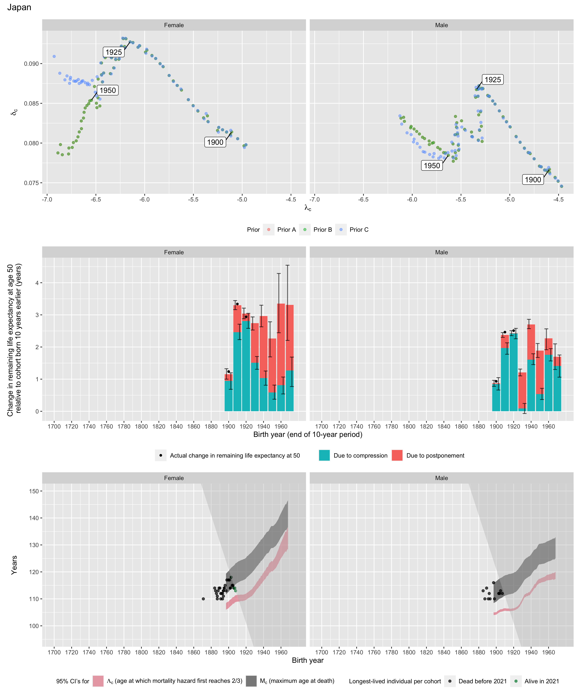
Longest-lived person in each cohort
Sex | Age | Cohort | Alive | Name | Birth date | Death date | Source
Female | 110 | 1871 | N | Oto Michii | 1871-07-17 | 1982-01-10 | GRG
Female | 110 | 1887 | N | data withheld by IDL | 1887-01-09 | 1997-01-09 | GRG
Female | 110 | 1891 | N | data withheld by IDL | 1891-07-04 | 2001-08-28 | GRG
Female | 110 | 1893 | N | data withheld by IDL | 1893-01-03 | 2003-01-06 | GRG
Female | 113 | 1894 | N | Tsuneyo Toyonaga | 1894-05-21 | 2008-02-22 | GRG
Female | 113 | 1894 | N | Kaku Yamanaka | 1894-12-11 | 2008-04-05 | GRG
Female | 114 | 1895 | N | Kama Chinen | 1895-05-10 | 2010-05-02 | GRG
Female | 114 | 1895 | N | Chiyo Shiraishi | 1895-08-06 | 2009-11-19 | GRG
Female | 115 | 1896 | N | Chiyono Hasegawa | 1896-11-20 | 2011-12-02 | GRG
Female | 113 | 1897 | N | Komiya Miyazaki | 1897-08-20 | 2011-01-04 | GRG
Female | 117 | 1898 | N | Misao Okawa | 1898-03-05 | 2015-04-01 | GRG
Female | 117 | 1900 | N | Nabi Tajima | 1900-08-04 | 2018-04-21 | GRG
Female | 117 | 1901 | N | Chiyo Miyako | 1901-05-02 | 2018-07-22 | GRG
Female | 114 | 1902 | N | Mitsue Toyoda | 1902-02-15 | 2016-08-25 | GRG
Female | 114 | 1902 | N | Yukie Hino | 1902-04-17 | 2017-01-13 | GRG
Female | 118 | 1903 | Y | data withheld by IDL |  |  | IDL
Female | 118 | 1903 | N | data withheld by IDL |  |  | IDL
Female | 115 | 1904 | N | Shin Matsushita | 1904-03-30 | 2019-08-27 | GRG
Female | 115 | 1905 | N | Mina Kitagawa | 1905-11-03 | 2020-12-19 | GRG
Female | 115 | 1905 | N | Shigeyo Nakachi | 1905-02-01 | 2021-01-11 | GRG
Female | 114 | 1906 | Y | data withheld by IDL |  |  | IDL
Female | 114 | 1906 | N | data withheld by IDL |  |  | IDL
Female | 114 | 1907 | N | Hama Yasukawa | 1907-01-19 | 2021-05-23 | GRG
Female | 114 | 1907 | N | Yoshi Baba | 1907-06-03 | 2022-01-04 | GRG
Female | 114 | 1907 | Y | data withheld by IDL |  |  | IDL
Female | 113 | 1908 | Y | data withheld by IDL |  |  | IDL
Male | 116 | 1897 | N | Jiroemon Kimura | 1897-04-19 | 2013-06-12 | GRG
Male | 110 | 1898 | N | Takashi Hattori | 1898-03-12 | 2009-01-12 | GRG
Male | 112 | 1903 | N | Sakari Momoi | 1903-02-05 | 2015-07-05 | GRG
Male | 112 | 1903 | N | Yasutaro Koide | 1903-03-13 | 2016-01-19 | GRG
Male | 112 | 1904 | N | Masamitsu Yoshida | 1904-05-30 | 2016-10-29 | GRG
Male | 113 | 1905 | N | Masazou Nonaka | 1905-07-25 | 2019-01-20 | GRG
Male | 112 | 1907 | N | Chitetsu Watanabe | 1907-03-05 | 2020-02-23 | GRG
Female | 114 | 1884 | N | data withheld by IDL |  |  | IDL
Female | 113 | 1885 | N | data withheld by IDL |  |  | IDL
Female | 112 | 1886 | N | data withheld by IDL |  |  | IDL
Female | 111 | 1887 | N | data withheld by IDL |  |  | IDL
Female | 113 | 1888 | N | data withheld by IDL |  |  | IDL
Female | 114 | 1889 | N | data withheld by IDL |  |  | IDL
Female | 114 | 1890 | N | data withheld by IDL |  |  | IDL
Female | 112 | 1891 | N | data withheld by IDL |  |  | IDL
Female | 112 | 1892 | N | data withheld by IDL |  |  | IDL
Female | 112 | 1893 | N | data withheld by IDL |  |  | IDL
Female | 111 | 1894 | N | data withheld by IDL |  |  | IDL
Male | 113 | 1885 | N | data withheld by IDL |  |  | IDL
Male | 110 | 1887 | N | data withheld by IDL |  |  | IDL
Male | 114 | 1889 | N | data withheld by IDL |  |  | IDL
Male | 110 | 1891 | N | data withheld by IDL |  |  | IDL
Male | 112 | 1892 | N | data withheld by IDL |  |  | IDL
Male | 110 | 1893 | N | data withheld by IDL |  |  | IDL

