95% CI’s for Gamma (age at which mortality hazard first reaches 2/3)
and M (maximum age at death)
 | Male |  |  |  | Female
 | Gamma |  | M |  | Gamma |  | M
Cohort | Lower 95% CI | Upper 95% CI | Lower 95% CI | Upper 95% CI | Lower 95% CI | Upper 95% CI | Lower 95% CI | Upper 95% CI
1890 | 105.5 | 106.3 | 110.5 | 118.0 | 107.6 | 109.5 | 114.1 | 121.7
1900 | 105.3 | 106.1 | 110.7 | 118.1 | 107.3 | 108.9 | 114.5 | 122.1
1910 | 105.5 | 106.3 | 111.4 | 119.0 | 106.7 | 108.3 | 114.8 | 122.4
1920 | 107.2 | 108.0 | 113.5 | 121.0 | 107.5 | 109.1 | 116.0 | 123.5
1930 | 111.7 | 112.8 | 117.5 | 125.0 | 109.5 | 111.3 | 117.8 | 125.4
1940 | 114.4 | 115.7 | 120.3 | 127.9 | 110.3 | 112.1 | 118.8 | 126.5
1950 | 115.0 | 117.0 | 122.0 | 129.6 | 109.7 | 111.9 | 119.5 | 127.2
1960 | 109.4 | 114.0 | 118.5 | 126.9 | 110.3 | 114.2 | 120.4 | 128.5
1970 | 105.6 | 115.9 | 115.9 | 127.1 | 110.4 | 116.5 | 120.8 | 129.9
95% CI’s for the change in remaining life expectancy at age 50
relative to cohort born 10 years earlier (years)
 | Due to postponement |  |  |  |  |  | Due to compression
 | Male |  |  | Female |  |  | Male |  |  | Female
Cohort | Lower 95% CI | Median | Upper 95% CI | Lower 95% CI | Median | Upper 95% CI | Lower 95% CI | Median | Upper 95% CI | Lower 95% CI | Median | Upper 95% CI
1890 | -0.1 | 0.0 | 0.1 | -0.1 | 0.0 | 0.2 | 0.1 | 0.4 | 0.6 | 1.0 | 1.2 | 1.4
1900 | -0.1 | -0.0 | 0.0 | -0.2 | -0.1 | -0.1 | 0.3 | 0.5 | 0.7 | 1.2 | 1.4 | 1.6
1910 | -0.0 | 0.1 | 0.1 | -0.3 | -0.2 | -0.1 | 0.6 | 0.8 | 1.0 | 1.2 | 1.4 | 1.6
1920 | 0.4 | 0.5 | 0.5 | 0.2 | 0.3 | 0.4 | 1.1 | 1.2 | 1.4 | 0.5 | 0.6 | 0.8
1930 | 1.1 | 1.3 | 1.4 | 0.6 | 0.8 | 0.9 | 0.9 | 1.0 | 1.2 | 0.4 | 0.6 | 0.8
1940 | 0.6 | 0.8 | 1.0 | 0.1 | 0.3 | 0.5 | 1.3 | 1.5 | 1.7 | 0.8 | 0.9 | 1.1
1950 | -0.0 | 0.3 | 0.6 | -0.5 | -0.2 | 0.2 | 0.7 | 0.9 | 1.1 | 0.9 | 1.1 | 1.2
1960 | -2.1 | -1.3 | -0.6 | -0.1 | 0.5 | 1.2 | 0.1 | 0.3 | 0.6 | -0.5 | -0.3 | -0.1
1970 | -1.6 | -0.4 | 0.9 | -0.4 | 0.5 | 1.3 | 0.2 | 0.5 | 0.8 | 0.3 | 0.6 | 0.9
Note: The greyed-out values refer to results of our model that depend heavily on the modelling assumptions we use (the Bayesian prior) rather than the actual data. Results before this point appear to be robust to the choice of prior.
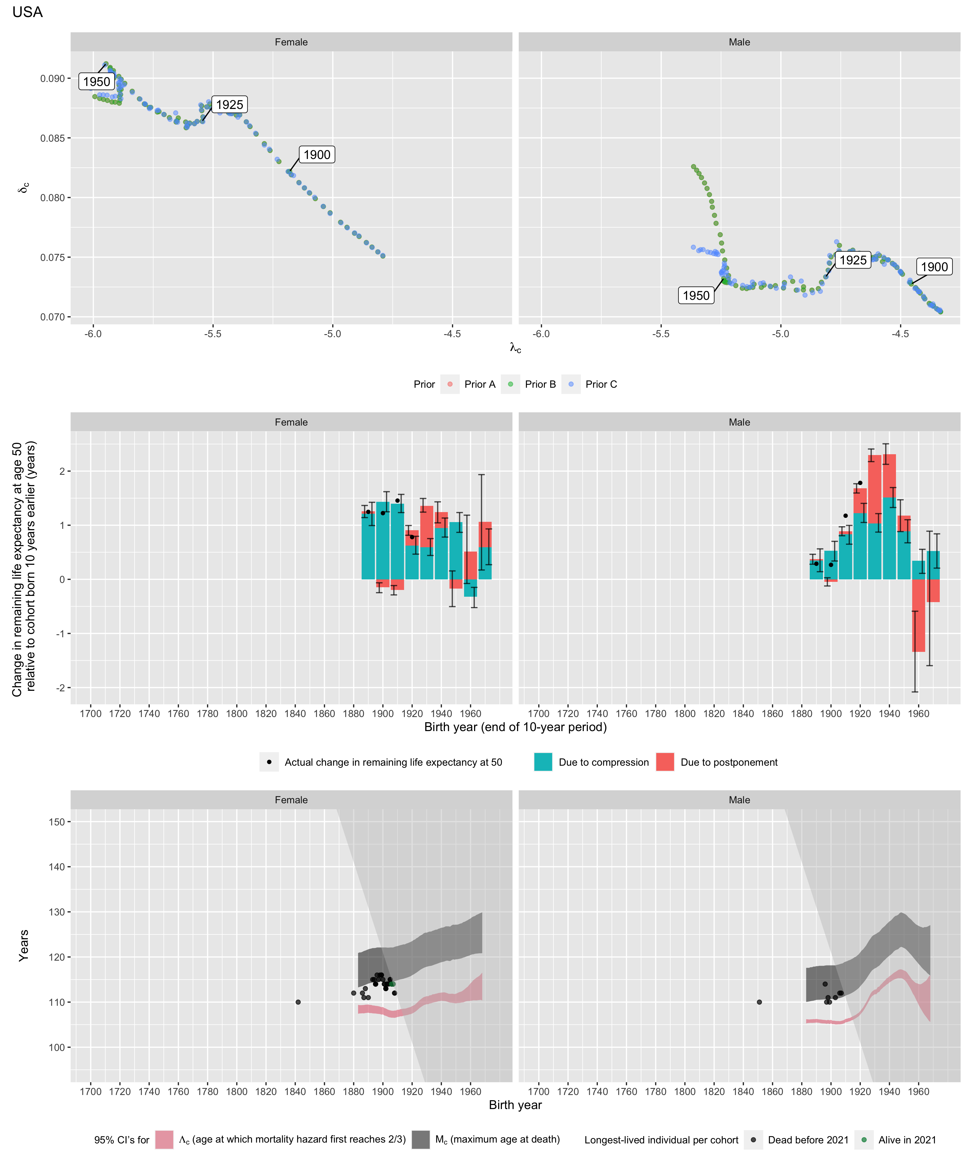
Longest-lived person in each cohort
Sex | Age | Cohort | Alive | Name | Birth date | Death date | Source
Female | 110 | 1842 | N | Velgjer Svien | 1842-10-10 | 2053-01-23 | GRG
Female | 112 | 1880 | N | Antoinette Huber | 1880-01-22 | 1992-03-01 | GRG
Female | 112 | 1886 | N | Julia Nutwell | 1886-07-30 | 1998-09-25 | GRG
Female | 111 | 1887 | N | Bina Harbaugh | 1887-12-01 | 1999-09-01 | GRG
Female | 113 | 1888 | N | Cora Wisner | 1888-01-10 | 2001-06-06 | GRG
Female | 111 | 1890 | N | Theresa Bernstein-Meyerowitz | 1890-03-01 | 2002-02-13 | GRG
Female | 115 | 1893 | N | Edna Parker | 1893-04-20 | 2008-11-26 | GRG
Female | 115 | 1894 | N | Gertrude Baines | 1894-04-06 | 2009-09-11 | GRG
Female | 114 | 1895 | N | Mary Josephine Ray | 1895-05-17 | 2010-03-07 | GRG
Female | 114 | 1895 | N | Olivia Patricia Thomas | 1895-06-29 | 2009-11-16 | GRG
Female | 114 | 1895 | N | Maggie Renfro | 1895-11-14 | 2010-01-22 | GRG
Female | 114 | 1895 | N | Neva Morris | 1895-08-03 | 2010-04-06 | GRG
Female | 116 | 1896 | N | Besse Cooper | 1896-08-26 | 2012-12-04 | GRG
Female | 115 | 1897 | N | Dina Manfredini | 1897-04-04 | 2012-12-17 | GRG
Female | 116 | 1898 | N | Gertrude Weaver | 1898-07-04 | 2015-04-06 | GRG
Female | 116 | 1899 | N | Jeralean Talley | 1899-05-23 | 2015-06-17 | GRG
Female | 116 | 1899 | N | Susannah Mushatt Jones | 1899-07-06 | 2016-05-12 | GRG
Female | 115 | 1900 | N | Antonia Gerena Rivera | 1900-05-19 | 2015-06-02 | GRG
Female | 114 | 1901 | N | Dominga Velasco | 1901-05-12 | 2015-10-11 | GRG
Female | 114 | 1901 | N | Emma Otis | 1901-10-22 | 2015-10-25 | GRG
Female | 113 | 1902 | N | Bertha Harris | 1902-01-03 | 2015-03-03 | GRG
Female | 113 | 1902 | N | Kathleen Snavely | 1902-02-16 | 2015-07-06 | GRG
Female | 113 | 1902 | N | Helen Wheat | 1902-09-16 | 2016-02-16 | GRG
Female | 113 | 1902 | N | Goldie Michelson | 1902-08-08 | 2016-07-08 | GRG
Female | 114 | 1903 | N | Ila Jones | 1903-08-21 | 2017-11-10 | GRG
Female | 114 | 1903 | N | Delphine Gibson | 1903-08-17 | 2018-05-09 | GRG
Female | 114 | 1904 | N | Lessie Brown | 1904-09-22 | 2019-01-08 | GRG
Female | 115 | 1905 | N | Iris Westman | 1905-08-28 | 2021-01-03 | GRG
Female | 115 | 1905 | N | Hester Ford | 1905-08-15 | 2021-04-17 | GRG
Female | 114 | 1906 | N | Minnie Whicker | 1906-07-24 | 2020-10-22 | GRG
Female | 114 | 1906 | N | Lucy Mirigian | 1906-08-15 | 2021-02-12 | GRG
Female | 114 | 1906 | Y | data withheld by IDL |  |  | IDL
Female | 114 | 1907 | N | Ellen Goodwill | 1907-02-02 | 2021-03-02 | GRG
Female | 114 | 1907 | N | Irene Dunham | 1907-12-16 | 2022-05-01 | GRG
Female | 114 | 1907 | N | Mila Mangold | 1907-11-14 | 2022-07-02 | GRG
Female | 114 | 1907 | Y | data withheld by IDL |  |  | IDL
Female | 112 | 1908 | N | Edna Runyon | 1908-01-25 | 2020-04-06 | GRG
Female | 112 | 1908 | N | Stella Lennox | 1908-01-31 | 2020-12-06 | GRG
Male | 110 | 1851 | N | Sylvester Melvin | 1851-11-29 | 2062-03-12 | GRG
Male | 114 | 1896 | N | Walter Breuning | 1896-09-21 | 2011-04-14 | GRG
Male | 110 | 1897 | N | Harvey Hite | 1897-11-15 | 2008-02-16 | GRG
Male | 111 | 1898 | N | Garland Adair | 1898-07-30 | 2009-12-11 | GRG
Male | 110 | 1899 | N | Hilliard Hudson | 1899-02-23 | 2009-11-06 | GRG
Male | 111 | 1903 | N | Dr. Alexander Imich | 1903-02-04 | 2014-06-08 | GRG
Male | 112 | 1906 | N | Richard Overton | 1906-05-11 | 2018-12-27 | GRG
Male | 112 | 1907 | N | CP Crawford | 1907-08-25 | 2019-11-23 | GRG

