95% CI’s for Gamma (age at which mortality hazard first reaches 2/3)
and M (maximum age at death)
 | Male |  |  |  | Female
 | Gamma |  | M |  | Gamma |  | M
Cohort | Lower 95% CI | Upper 95% CI | Lower 95% CI | Upper 95% CI | Lower 95% CI | Upper 95% CI | Lower 95% CI | Upper 95% CI
1860 | 99.2 | 100.4 | 103.1 | 110.7 | 101.1 | 102.8 | 105.8 | 113.4
1870 | 100.0 | 101.2 | 103.8 | 111.3 | 101.6 | 103.2 | 106.5 | 114.0
1880 | 101.8 | 103.1 | 105.1 | 112.6 | 102.2 | 103.8 | 107.1 | 114.6
1890 | 103.1 | 104.6 | 106.4 | 113.9 | 103.2 | 104.9 | 108.2 | 115.8
1900 | 102.9 | 104.3 | 107.0 | 114.6 | 103.5 | 105.2 | 109.4 | 116.9
1910 | 103.4 | 104.9 | 108.3 | 115.9 | 104.8 | 106.6 | 111.2 | 118.8
1920 | 104.9 | 106.6 | 109.8 | 117.3 | 106.6 | 108.3 | 113.1 | 120.7
1930 | 109.5 | 111.5 | 114.4 | 122.0 | 110.7 | 112.9 | 117.5 | 125.3
1940 | 115.3 | 118.3 | 119.0 | 126.9 | 115.9 | 119.3 | 122.0 | 129.9
1950 | 116.2 | 120.4 | 121.0 | 129.3 | 117.1 | 121.2 | 123.9 | 132.1
1960 | 115.5 | 120.6 | 121.4 | 130.1 | 117.9 | 123.4 | 125.3 | 134.0
1970 | 113.9 | 119.9 | 121.1 | 130.0 | 117.3 | 123.5 | 125.5 | 134.6
95% CI’s for the change in remaining life expectancy at age 50
relative to cohort born 10 years earlier (years)
 | Due to postponement |  |  |  |  |  | Due to compression
 | Male |  |  | Female |  |  | Male |  |  | Female
Cohort | Lower 95% CI | Median | Upper 95% CI | Lower 95% CI | Median | Upper 95% CI | Lower 95% CI | Median | Upper 95% CI | Lower 95% CI | Median | Upper 95% CI
1860 | -0.9 | -0.6 | -0.3 | -1.3 | -0.9 | -0.5 | 3.9 | 4.4 | 5.0 | 5.3 | 6.0 | 6.7
1870 | 0.0 | 0.2 | 0.4 | -0.1 | 0.2 | 0.4 | -0.7 | -0.3 | 0.2 | -0.3 | 0.2 | 0.7
1880 | 0.3 | 0.5 | 0.6 | -0.0 | 0.2 | 0.4 | -1.3 | -0.8 | -0.4 | -0.7 | -0.2 | 0.4
1890 | 0.2 | 0.4 | 0.5 | 0.1 | 0.3 | 0.6 | -0.7 | -0.1 | 0.4 | -0.2 | 0.4 | 0.9
1900 | -0.3 | -0.1 | 0.1 | -0.2 | 0.1 | 0.4 | 0.9 | 1.5 | 1.9 | 0.9 | 1.4 | 1.9
1910 | -0.1 | 0.2 | 0.4 | 0.2 | 0.5 | 0.8 | 0.6 | 1.1 | 1.7 | 0.4 | 0.9 | 1.4
1920 | 0.2 | 0.5 | 0.7 | 0.4 | 0.7 | 1.0 | 0.1 | 0.6 | 1.1 | 0.6 | 1.1 | 1.6
1930 | 1.2 | 1.5 | 1.8 | 1.5 | 1.8 | 2.2 | 0.3 | 0.7 | 1.2 | 0.9 | 1.5 | 2.0
1940 | 1.5 | 1.9 | 2.4 | 1.9 | 2.5 | 3.1 | 0.2 | 0.7 | 1.2 | 0.4 | 0.9 | 1.4
1950 | -0.2 | 0.5 | 1.2 | -0.1 | 0.6 | 1.4 | 0.6 | 1.2 | 1.9 | 0.3 | 0.8 | 1.4
1960 | -0.9 | -0.2 | 0.7 | -0.3 | 0.7 | 1.6 | 0.9 | 1.6 | 2.4 | -0.6 | 0.1 | 0.8
1970 | -1.4 | -0.4 | 0.4 | -1.1 | -0.2 | 0.8 | 0.8 | 2.1 | 3.5 | 0.3 | 1.6 | 2.8
Note: The greyed-out values refer to results of our model that depend heavily on the modelling assumptions we use (the Bayesian prior) rather than the actual data. Results before this point appear to be robust to the choice of prior.
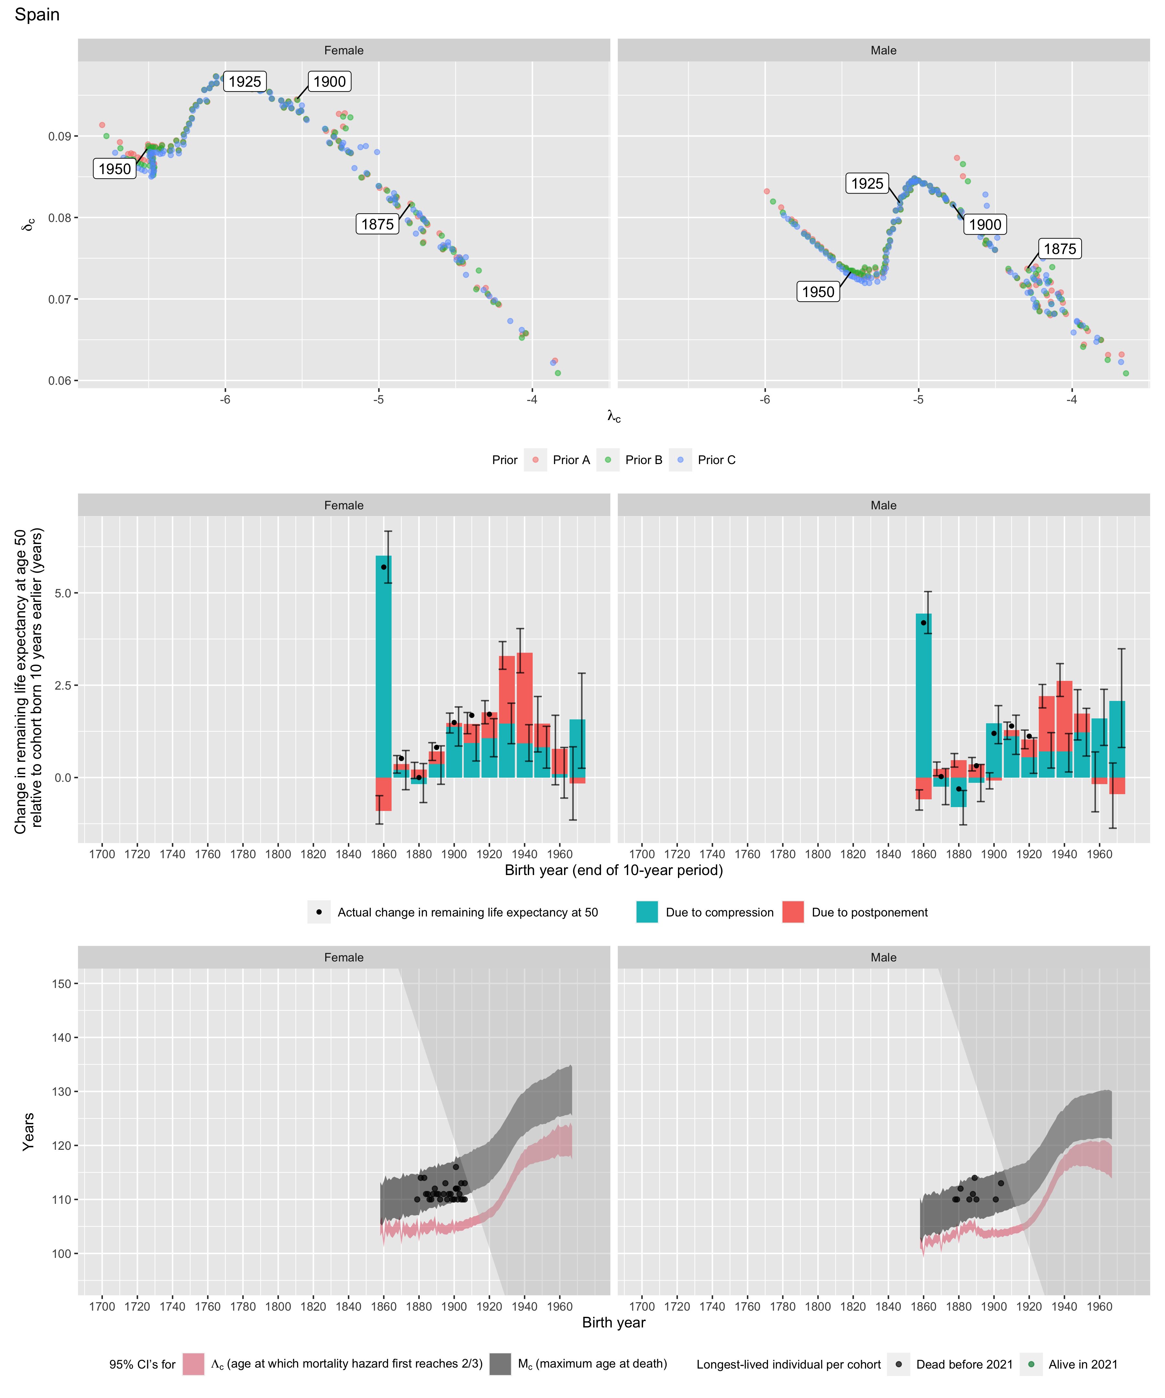
Longest-lived person in each cohort
Sex | Age | Cohort | Alive | Name | Birth date | Death date | Source
Female | 110 | 1879 | N | data withheld by IDL |  |  | IDL
Female | 114 | 1881 | N | data withheld by IDL |  |  | IDL
Female | 114 | 1883 | N | data withheld by IDL |  |  | IDL
Female | 111 | 1884 | N | data withheld by IDL |  |  | IDL
Female | 111 | 1885 | N | data withheld by IDL |  |  | IDL
Female | 110 | 1886 | N | data withheld by IDL |  |  | IDL
Female | 110 | 1887 | N | data withheld by IDL |  |  | IDL
Female | 111 | 1888 | N | data withheld by IDL |  |  | IDL
Female | 112 | 1889 | N | data withheld by IDL |  |  | IDL
Female | 111 | 1890 | N | data withheld by IDL |  |  | IDL
Female | 111 | 1891 | N | data withheld by IDL |  |  | IDL
Female | 110 | 1892 | N | data withheld by IDL |  |  | IDL
Female | 111 | 1894 | N | Lucia Madaria-Vesga | 1894-12-13 | 2006-02-02 | GRG
Female | 113 | 1895 | N | Manuela Fernandez-Fojaco | 1895-06-18 | 2009-01-06 | GRG
Female | 110 | 1896 | N | data withheld by IDL |  |  | IDL
Female | 111 | 1897 | N | data withheld by IDL |  |  | IDL
Female | 111 | 1898 | N | Maria de la O Soria-Berbel | 1898-04-09 | 2009-12-23 | GRG
Female | 110 | 1899 | N | data withheld by IDL |  |  | IDL
Female | 110 | 1900 | N | Maria de los Bueis-Rodriguez | 1900-07-06 | 2010-07-08 | GRG
Female | 116 | 1901 | N | Ana Vela-Rubio | 1901-10-29 | 2017-12-15 | GRG
Female | 112 | 1901 | N | Francisca Garcia-Torres | 1901-09-13 | 2014-02-25 | GRG
Female | 112 | 1901 | N | Maria Concha Perez-Cidad | 1901-12-09 | 2014-09-30 | GRG
Female | 110 | 1902 | N | Francisca Villan-Perez | 1902-09-17 | 2013-01-10 | GRG
Female | 112 | 1902 | N | data withheld by IDL |  |  | IDL
Female | 111 | 1903 | N | Remei Company-Ventura | 1903-02-10 | 2014-05-28 | GRG
Female | 113 | 1904 | N | Avelina Mouzo Leis | 1904-12-27 | 2017-12-28 | GRG
Female | 110 | 1904 | N | data withheld by IDL |  |  | IDL
Female | 110 | 1905 | N | data withheld by IDL |  |  | IDL
Female | 113 | 1906 | N | Josefa Santos-Gonzalez | 1906-09-07 | 2019-12-22 | GRG
Female | 110 | 1906 | N | data withheld by IDL |  |  | IDL
Male | 110 | 1878 | N | data withheld by IDL |  |  | IDL
Male | 110 | 1879 | N | data withheld by IDL |  |  | IDL
Male | 112 | 1881 | N | data withheld by IDL |  |  | IDL
Male | 110 | 1886 | N | Gregorio Merino-Calvo | 1886-12-24 | 1997-09-09 | GRG
Male | 111 | 1888 | N | data withheld by IDL |  |  | IDL
Male | 114 | 1889 | N | data withheld by IDL |  |  | IDL
Male | 110 | 1890 | N | data withheld by IDL |  |  | IDL
Male | 110 | 1901 | N | data withheld by IDL |  |  | IDL
Male | 113 | 1904 | N | Francisco Nunez-Olivera | 1904-12-13 | 2018-01-29 | GRG

