95% CI’s for Gamma (age at which mortality hazard first reaches 2/3)
and M (maximum age at death)
 | Male |  |  |  | Female
 | Gamma |  | M |  | Gamma |  | M
Cohort | Lower 95% CI | Upper 95% CI | Lower 95% CI | Upper 95% CI | Lower 95% CI | Upper 95% CI | Lower 95% CI | Upper 95% CI
1880 | 102.7 | 103.3 | 105.2 | 112.7 | 105.3 | 106.8 | 107.9 | 115.4
1890 | 104.1 | 104.8 | 106.5 | 114.0 | 107.3 | 108.8 | 110.1 | 117.7
1900 | 104.7 | 105.5 | 106.8 | 114.3 | 107.6 | 109.0 | 110.9 | 118.4
1910 | 104.8 | 105.5 | 107.9 | 115.4 | 106.9 | 108.2 | 111.5 | 119.0
1920 | 107.4 | 108.1 | 110.4 | 117.9 | 108.2 | 109.6 | 113.3 | 120.8
1930 | 112.0 | 113.0 | 114.9 | 122.4 | 111.5 | 113.1 | 116.4 | 124.0
1940 | 116.2 | 117.9 | 119.3 | 126.9 | 113.4 | 115.3 | 118.5 | 126.2
1950 | 118.0 | 120.4 | 122.1 | 129.9 | 113.5 | 116.0 | 119.8 | 127.6
1960 | 117.9 | 122.2 | 123.2 | 131.4 | 114.1 | 117.6 | 121.0 | 129.1
1970 | 117.6 | 123.7 | 123.3 | 132.4 | 114.4 | 118.9 | 121.6 | 130.0
95% CI’s for the change in remaining life expectancy at age 50
relative to cohort born 10 years earlier (years)
 | Due to postponement |  |  |  |  |  | Due to compression
 | Male |  |  | Female |  |  | Male |  |  | Female
Cohort | Lower 95% CI | Median | Upper 95% CI | Lower 95% CI | Median | Upper 95% CI | Lower 95% CI | Median | Upper 95% CI | Lower 95% CI | Median | Upper 95% CI
1880 | 0.1 | 0.2 | 0.4 | 0.3 | 0.4 | 0.6 | -0.4 | -0.2 | 0.1 | 0.2 | 0.5 | 0.8
1890 | 0.3 | 0.4 | 0.5 | 0.5 | 0.6 | 0.7 | -0.4 | -0.2 | 0.0 | 0.9 | 1.1 | 1.4
1900 | 0.0 | 0.2 | 0.3 | -0.0 | 0.1 | 0.2 | -0.9 | -0.7 | -0.5 | 0.6 | 0.8 | 1.1
1910 | -0.1 | 0.0 | 0.2 | -0.4 | -0.3 | -0.1 | 1.1 | 1.4 | 1.6 | 1.9 | 2.1 | 2.4
1920 | 0.6 | 0.7 | 0.8 | 0.4 | 0.5 | 0.7 | 0.5 | 0.8 | 1.0 | 0.6 | 0.8 | 1.0
1930 | 1.2 | 1.4 | 1.6 | 1.1 | 1.3 | 1.5 | 1.2 | 1.5 | 1.7 | 0.5 | 0.8 | 1.0
1940 | 1.1 | 1.5 | 1.7 | 0.5 | 0.8 | 1.1 | 1.6 | 1.9 | 2.1 | 0.8 | 1.1 | 1.3
1950 | 0.2 | 0.7 | 1.2 | -0.3 | 0.2 | 0.6 | 1.3 | 1.6 | 1.9 | 0.9 | 1.1 | 1.4
1960 | -0.4 | 0.3 | 1.1 | -0.2 | 0.4 | 1.1 | 0.7 | 1.0 | 1.3 | 0.3 | 0.6 | 0.8
1970 | -0.5 | 0.2 | 1.0 | -0.2 | 0.3 | 1.0 | 0.1 | 0.6 | 1.1 | 0.2 | 0.7 | 1.2
Note: The greyed-out values refer to results of our model that depend heavily on the modelling assumptions we use (the Bayesian prior) rather than the actual data. Results before this point appear to be robust to the choice of prior.
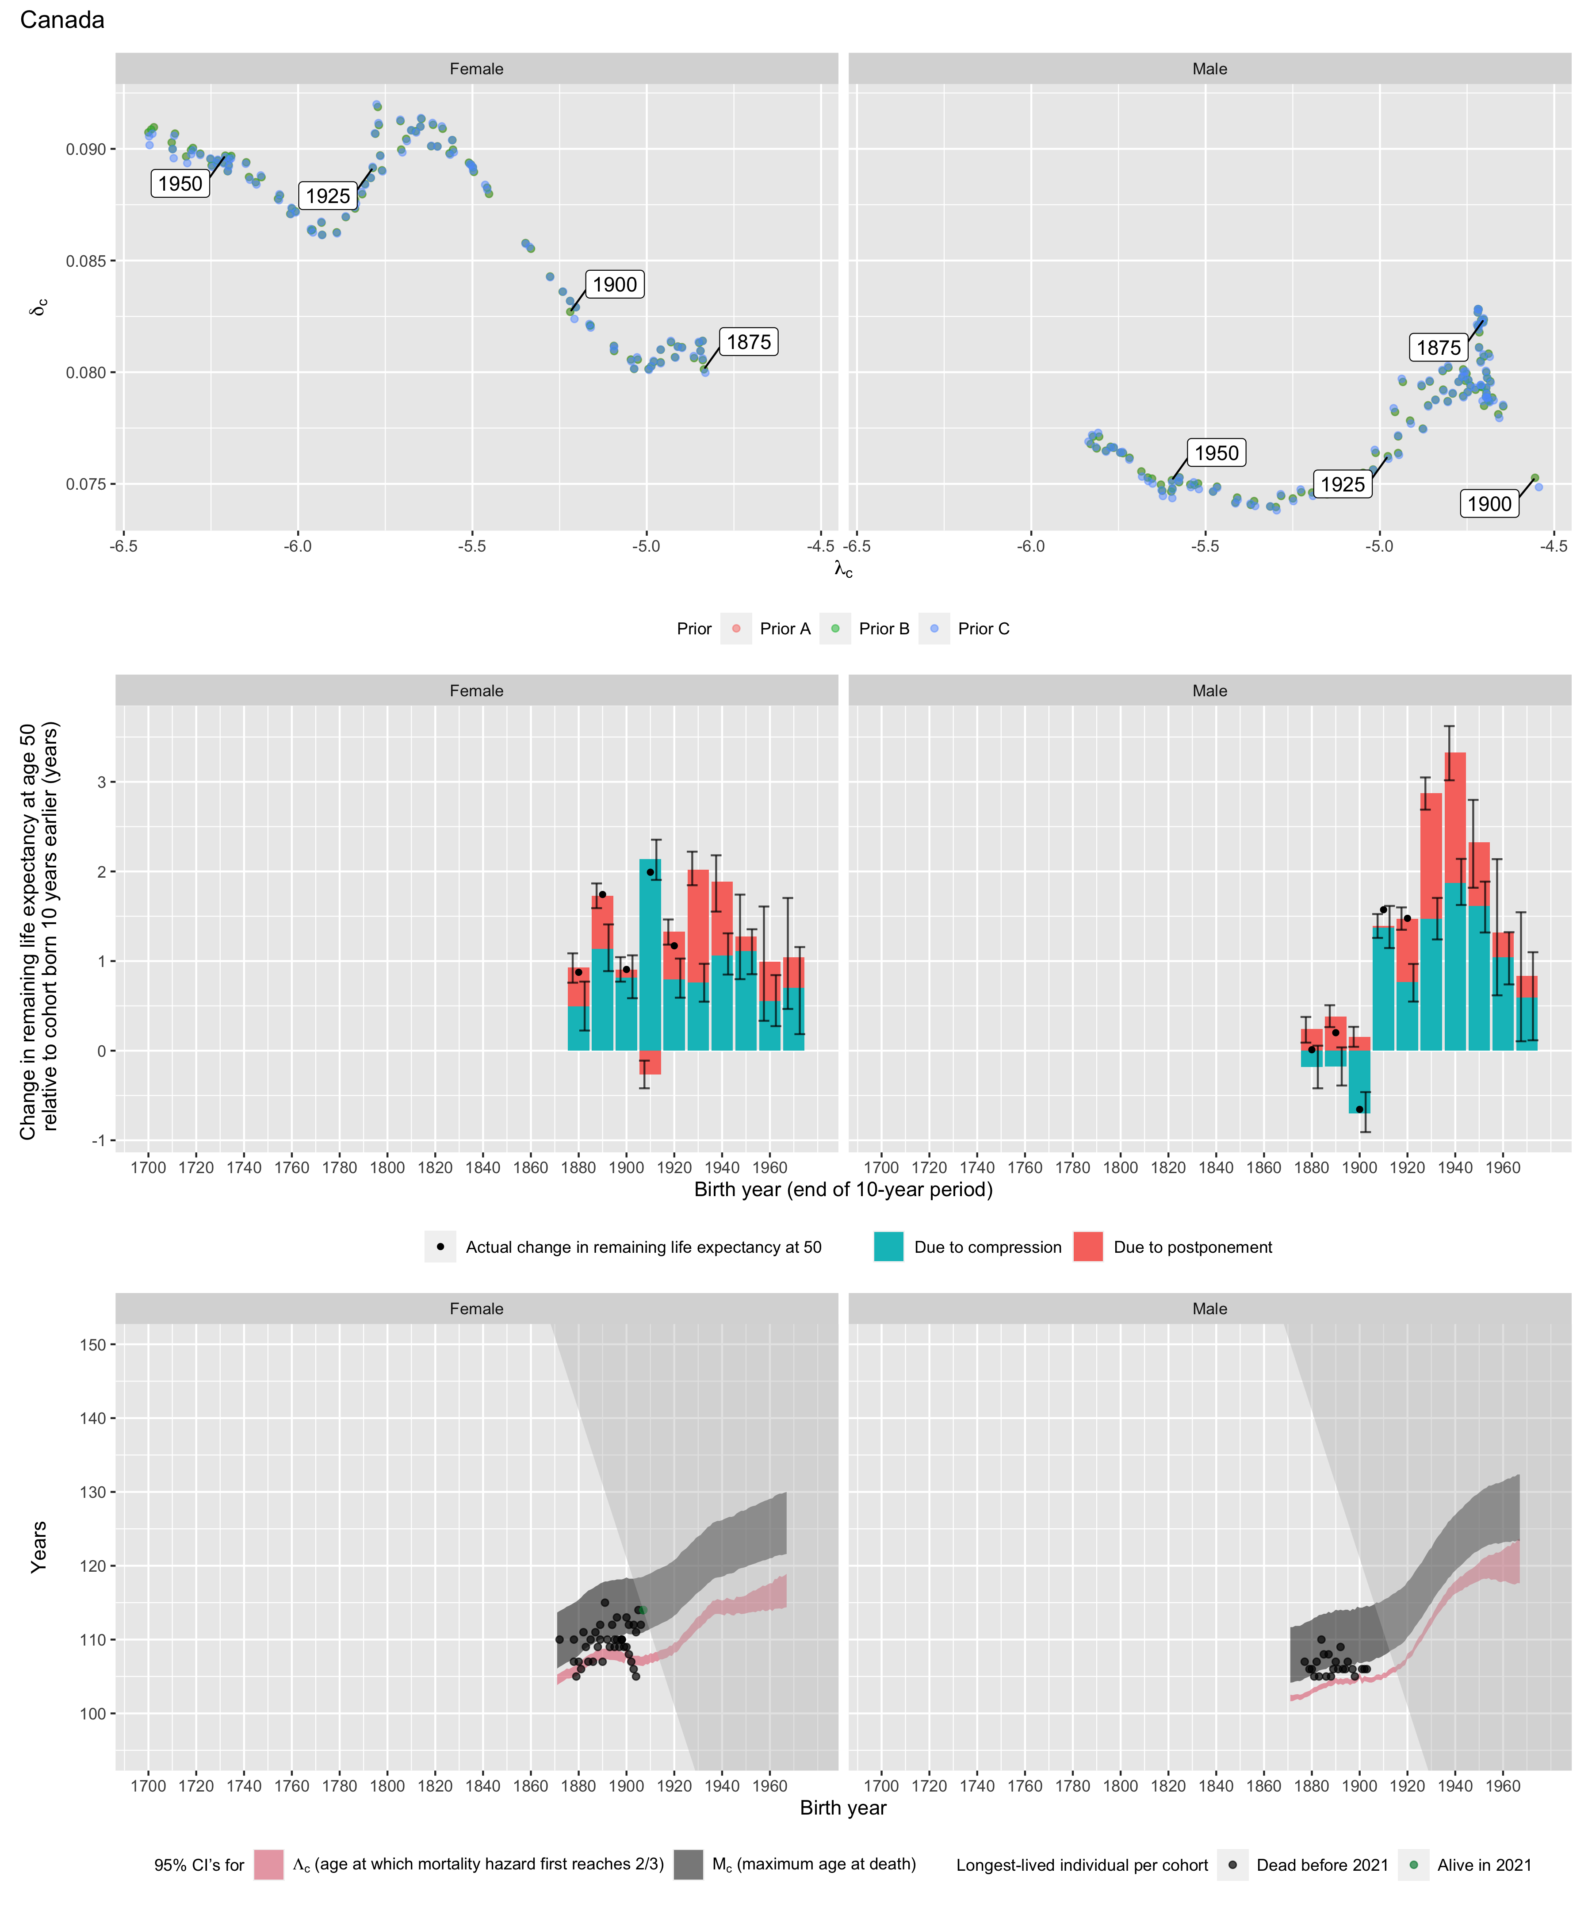
Longest-lived person in each cohort
Sex | Age | Cohort | Alive | Name | Birth date | Death date | Source
Female | 110 | 1872 | N | data withheld by IDL |  |  | IDL
Female | 107 | 1878 | N | data withheld by IDL |  |  | IDL
Female | 110 | 1878 | N | Ellen Green | 1878-07-19 | 1988-12-04 | GRG
Female | 105 | 1879 | N | data withheld by IDL |  |  | IDL
Female | 107 | 1880 | N | data withheld by IDL |  |  | IDL
Female | 106 | 1881 | N | data withheld by IDL |  |  | IDL
Female | 111 | 1882 | N | data withheld by IDL |  |  | IDL
Female | 109 | 1883 | N | data withheld by IDL |  |  | IDL
Female | 107 | 1884 | N | data withheld by IDL |  |  | IDL
Female | 110 | 1885 | N | data withheld by IDL |  |  | IDL
Female | 107 | 1886 | N | data withheld by IDL |  |  | IDL
Female | 111 | 1887 | N | data withheld by IDL |  |  | IDL
Female | 109 | 1888 | N | data withheld by IDL |  |  | IDL
Female | 110 | 1889 | N | Elizabeth Middler | 1889-10-12 | 2000-04-19 | GRG
Female | 112 | 1889 | N | data withheld by IDL |  |  | IDL
Female | 107 | 1890 | N | data withheld by IDL |  |  | IDL
Female | 115 | 1891 | N | data withheld by IDL |  |  | IDL
Female | 110 | 1892 | N | data withheld by IDL |  |  | IDL
Female | 109 | 1893 | N | data withheld by IDL |  |  | IDL
Female | 112 | 1894 | N | data withheld by IDL |  |  | IDL
Female | 109 | 1895 | N | data withheld by IDL |  |  | IDL
Female | 110 | 1895 | N | Mary D'All-Parsons | 1895-11-08 | 2006-03-15 | GRG
Female | 113 | 1896 | N | Margaret Fitzgerald | 1896-09-16 | 2009-10-20 | GRG
Female | 110 | 1896 | N | data withheld by IDL |  |  | IDL
Female | 109 | 1897 | N | data withheld by IDL |  |  | IDL
Female | 110 | 1898 | N | Judith Pinard | 1898-07-03 | 2009-06-13 | GRG
Female | 110 | 1898 | N | Pasqualina Franco | 1898-12-02 | 2009-08-16 | GRG
Female | 110 | 1898 | N | Mary Sloan | 1898-06-11 | 2008-08-12 | GRG
Female | 109 | 1899 | N | data withheld by IDL |  |  | IDL
Female | 113 | 1900 | N | Merle Barwis | 1900-12-23 | 2014-11-22 | GRG
Female | 109 | 1900 | N | data withheld by IDL |  |  | IDL
Female | 112 | 1901 | N | Flora Thibodeau | 1901-03-20 | 2014-01-22 | GRG
Female | 108 | 1901 | N | data withheld by IDL |  |  | IDL
Female | 107 | 1902 | N | data withheld by IDL |  |  | IDL
Female | 112 | 1903 | N | Orma Slack | 1903-02-19 | 2015-04-13 | GRG
Female | 106 | 1903 | N | data withheld by IDL |  |  | IDL
Female | 105 | 1904 | N | data withheld by IDL |  |  | IDL
Female | 111 | 1904 | N | Lilian Cornell | 1904-08-21 | 2016-01-11 | GRG
Female | 114 | 1905 | N | Ellen Gibb | 1905-04-26 | 2019-06-05 | GRG
Female | 112 | 1906 | N | Henrietta Irwin | 1906-05-27 | 2019-01-15 | GRG
Female | 114 | 1907 | N | Cecile Klein | 1907-06-15 | 2022-01-13 | GRG
Female | 114 | 1907 | N | Phyllis Ridgway | 1907-03-10 | 2021-06-04 | GRG
Female | 114 | 1907 | Y | data withheld by IDL |  |  | IDL
Male | 107 | 1877 | N | data withheld by IDL |  |  | IDL
Male | 106 | 1879 | N | data withheld by IDL |  |  | IDL
Male | 106 | 1880 | N | data withheld by IDL |  |  | IDL
Male | 105 | 1881 | N | data withheld by IDL |  |  | IDL
Male | 107 | 1882 | N | data withheld by IDL |  |  | IDL
Male | 105 | 1883 | N | data withheld by IDL |  |  | IDL
Male | 110 | 1884 | N | Chester Pushie | 1884-06-24 | 1994-07-22 | GRG
Male | 108 | 1885 | N | data withheld by IDL |  |  | IDL
Male | 105 | 1886 | N | data withheld by IDL |  |  | IDL
Male | 108 | 1887 | N | data withheld by IDL |  |  | IDL
Male | 105 | 1888 | N | data withheld by IDL |  |  | IDL
Male | 106 | 1889 | N | data withheld by IDL |  |  | IDL
Male | 107 | 1890 | N | data withheld by IDL |  |  | IDL
Male | 106 | 1891 | N | data withheld by IDL |  |  | IDL
Male | 109 | 1892 | N | data withheld by IDL |  |  | IDL
Male | 106 | 1893 | N | data withheld by IDL |  |  | IDL
Male | 106 | 1894 | N | data withheld by IDL |  |  | IDL
Male | 107 | 1895 | N | data withheld by IDL |  |  | IDL
Male | 106 | 1897 | N | data withheld by IDL |  |  | IDL
Male | 105 | 1898 | N | data withheld by IDL |  |  | IDL
Male | 106 | 1901 | N | data withheld by IDL |  |  | IDL
Male | 106 | 1902 | N | data withheld by IDL |  |  | IDL
Male | 106 | 1903 | N | data withheld by IDL |  |  | IDL

