95% CI’s for Gamma (age at which mortality hazard first reaches 2/3)
and M (maximum age at death)
 | Male |  |  |  | Female
 | Gamma |  | M |  | Gamma |  | M
Cohort | Lower 95% CI | Upper 95% CI | Lower 95% CI | Upper 95% CI | Lower 95% CI | Upper 95% CI | Lower 95% CI | Upper 95% CI
1830 | 97.0 | 98.0 | 101.5 | 109.0 | 97.6 | 98.6 | 102.2 | 109.8
1840 | 96.8 | 97.9 | 101.6 | 109.1 | 97.8 | 98.9 | 102.7 | 110.2
1850 | 96.9 | 97.9 | 101.9 | 109.4 | 97.9 | 99.1 | 103.3 | 110.8
1860 | 97.9 | 98.8 | 102.9 | 110.4 | 99.3 | 100.5 | 104.5 | 112.0
1870 | 99.4 | 100.4 | 104.1 | 111.6 | 100.5 | 101.7 | 105.7 | 113.2
1880 | 100.6 | 101.7 | 105.6 | 113.1 | 101.6 | 102.8 | 107.1 | 114.7
1890 | 101.7 | 102.7 | 106.5 | 114.0 | 102.7 | 103.9 | 108.8 | 116.3
1900 | 102.1 | 103.2 | 107.2 | 114.7 | 103.6 | 104.8 | 110.2 | 117.7
1910 | 103.7 | 104.8 | 109.1 | 116.6 | 105.2 | 106.5 | 112.3 | 119.8
1920 | 105.5 | 106.8 | 110.3 | 117.9 | 106.8 | 108.2 | 113.5 | 121.2
1930 | 111.0 | 112.8 | 115.7 | 123.3 | 112.1 | 114.0 | 119.0 | 126.6
1940 | 114.3 | 116.6 | 119.6 | 127.3 | 118.0 | 120.6 | 124.5 | 132.3
1950 | 111.9 | 115.1 | 118.5 | 126.5 | 117.2 | 120.7 | 124.4 | 132.4
1960 | 109.4 | 113.9 | 117.3 | 125.6 | 116.4 | 120.8 | 124.2 | 132.6
1970 | 108.8 | 113.9 | 117.4 | 125.9 | 115.9 | 121.6 | 124.5 | 133.4
95% CI’s for the change in remaining life expectancy at age 50
relative to cohort born 10 years earlier (years)
 | Due to postponement |  |  |  |  |  | Due to compression
 | Male |  |  | Female |  |  | Male |  |  | Female
Cohort | Lower 95% CI | Median | Upper 95% CI | Lower 95% CI | Median | Upper 95% CI | Lower 95% CI | Median | Upper 95% CI | Lower 95% CI | Median | Upper 95% CI
1830 | -0.8 | -0.5 | -0.3 | -0.9 | -0.6 | -0.4 | 2.0 | 2.4 | 2.7 | 2.5 | 2.9 | 3.4
1840 | -0.2 | -0.0 | 0.1 | -0.1 | 0.1 | 0.2 | 0.1 | 0.3 | 0.6 | 0.1 | 0.4 | 0.7
1850 | -0.1 | 0.0 | 0.2 | -0.1 | 0.1 | 0.2 | 0.3 | 0.6 | 0.9 | 0.5 | 0.8 | 1.1
1860 | 0.1 | 0.3 | 0.4 | 0.2 | 0.4 | 0.5 | 0.0 | 0.3 | 0.6 | 0.1 | 0.4 | 0.7
1870 | 0.2 | 0.4 | 0.5 | 0.2 | 0.4 | 0.5 | -0.1 | 0.2 | 0.5 | 0.2 | 0.5 | 0.9
1880 | 0.2 | 0.4 | 0.5 | 0.1 | 0.3 | 0.5 | 0.4 | 0.6 | 0.9 | 0.6 | 0.9 | 1.2
1890 | 0.1 | 0.3 | 0.4 | 0.2 | 0.4 | 0.5 | -0.2 | 0.1 | 0.4 | 1.0 | 1.2 | 1.6
1900 | -0.0 | 0.1 | 0.3 | 0.1 | 0.3 | 0.5 | -0.0 | 0.3 | 0.6 | 1.4 | 1.6 | 2.0
1910 | 0.3 | 0.4 | 0.6 | 0.4 | 0.6 | 0.9 | 0.3 | 0.5 | 0.8 | 0.7 | 1.0 | 1.3
1920 | 0.3 | 0.6 | 0.7 | 0.4 | 0.6 | 0.9 | 0.3 | 0.6 | 0.9 | 0.7 | 1.0 | 1.3
1930 | 1.4 | 1.7 | 2.0 | 1.9 | 2.2 | 2.6 | 0.5 | 0.9 | 1.2 | 0.7 | 1.0 | 1.3
1940 | 0.7 | 1.2 | 1.6 | 1.9 | 2.5 | 3.1 | 2.1 | 2.5 | 2.9 | 0.7 | 1.1 | 1.5
1950 | -1.4 | -0.8 | -0.1 | -0.9 | -0.1 | 0.6 | 1.7 | 2.0 | 2.4 | 0.7 | 1.0 | 1.4
1960 | -1.4 | -0.8 | 0.0 | -1.0 | -0.1 | 0.7 | 1.1 | 1.5 | 1.8 | 0.5 | 0.8 | 1.2
1970 | -0.8 | -0.2 | 0.6 | -0.8 | -0.0 | 0.9 | 0.4 | 0.9 | 1.4 | 0.3 | 0.9 | 1.7
Note: The greyed-out values refer to results of our model that depend heavily on the modelling assumptions we use (the Bayesian prior) rather than the actual data. Results before this point appear to be robust to the choice of prior.
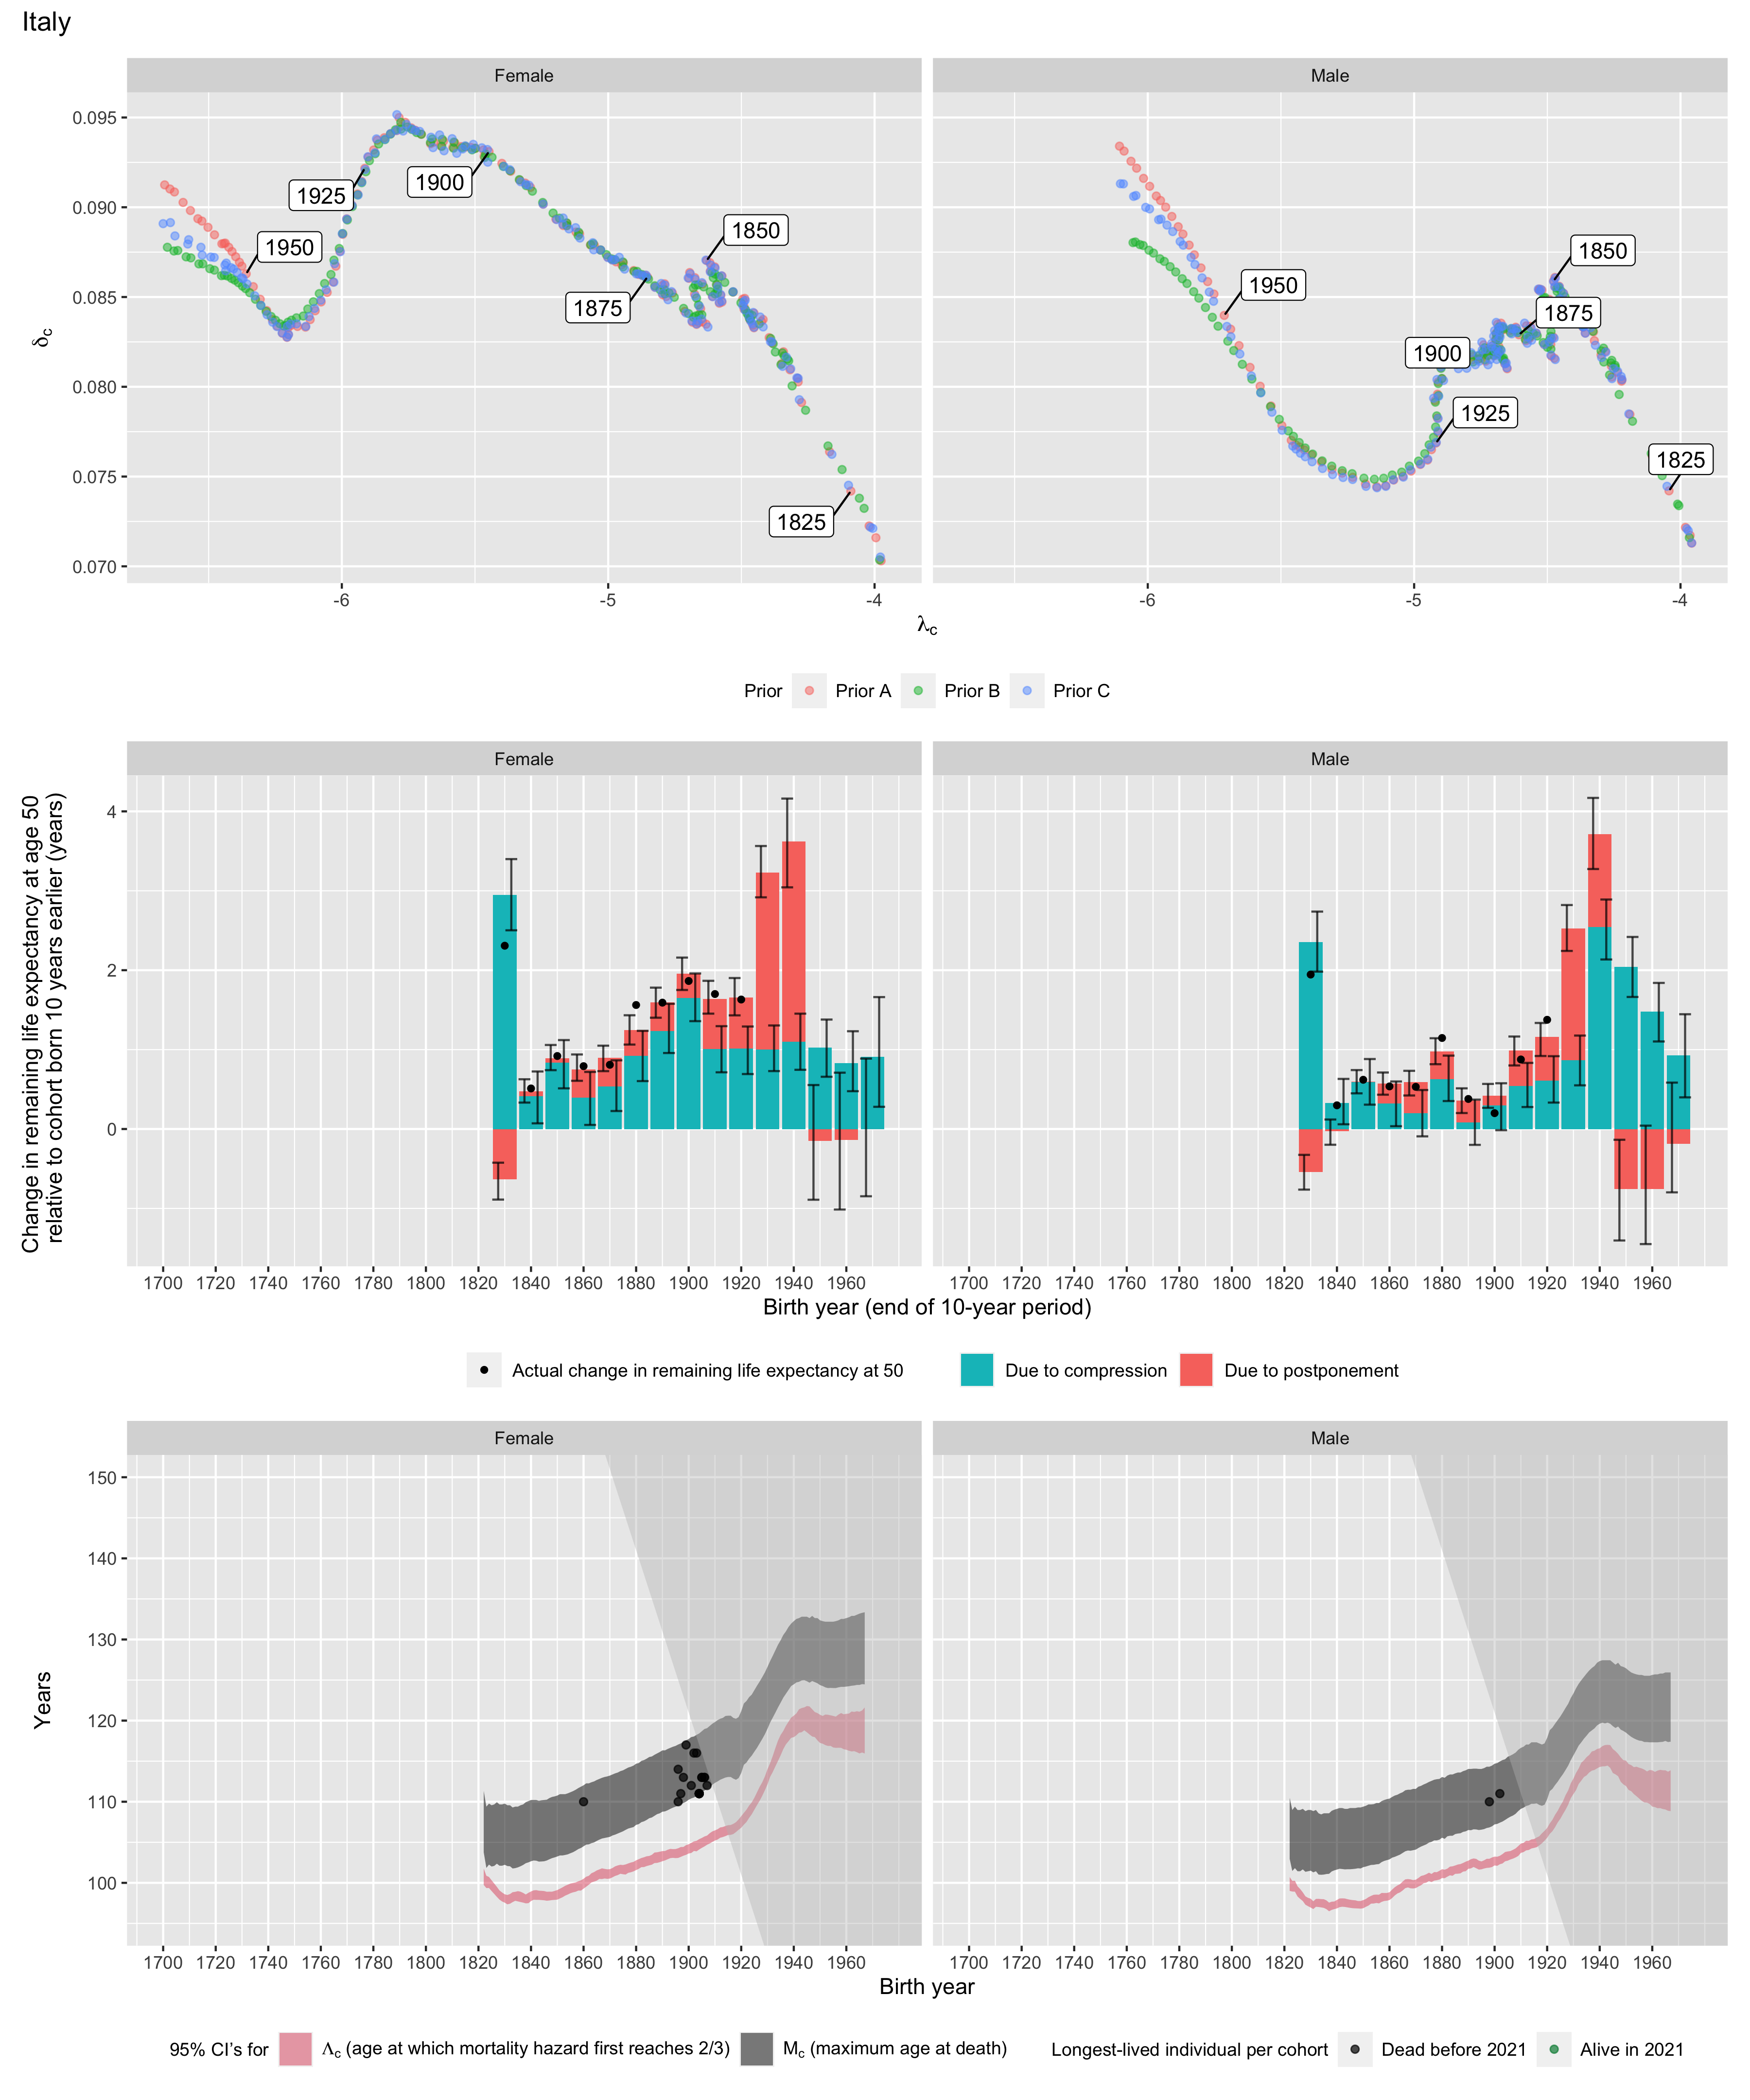
Longest-lived person in each cohort
Sex | Age | Cohort | Alive | Name | Birth date | Death date | Source
Female | 110 | 1860 | N | Vincenza Pannuti-Camera | 1860-09-16 | 1971-06-23 | GRG
Female | 110 | 1896 | N | data withheld by IDL |  |  | IDL
Female | 114 | 1896 | N | Venere Pizzinato-Papo | 1896-11-23 | 2011-08-02 | GRG
Female | 111 | 1897 | N | Maria-Elisa Moro-Lucchini | 1897-02-11 | 2008-11-02 | GRG
Female | 113 | 1898 | N | Stella Nardari-Vecchiato | 1898-12-23 | 2012-02-23 | GRG
Female | 117 | 1899 | N | Emma Morano-Martinuzzi | 1899-11-29 | 2017-04-15 | GRG
Female | 112 | 1901 | N | Rosa Bandini-Alberghi | 1901-09-11 | 2014-06-12 | GRG
Female | 116 | 1902 | N | Giuseppina Projetto-Frau | 1902-05-30 | 2018-07-06 | GRG
Female | 116 | 1903 | N | Maria-Giuseppa Robucci-Nargiso | 1903-03-20 | 2019-06-18 | GRG
Female | 111 | 1904 | N | Maria Crescini-Carrara | 1904-01-20 | 2015-12-17 | GRG
Female | 111 | 1904 | N | Filomena Marongiu-Marongiu | 1904-10-23 | 2016-02-23 | GRG
Female | 111 | 1904 | N | Maria Mattivi-Mattivi | 1904-11-29 | 2016-05-29 | GRG
Female | 111 | 1904 | N | Maria Santa Butera-Catalano | 1904-12-02 | 2016-01-14 | GRG
Female | 111 | 1904 | N | Maria Granello-Grilletti | 1904-12-11 | 2016-08-11 | GRG
Female | 113 | 1905 | N | Mariannina Genovese | 1905-10-15 | 2019-01-01 | GRG
Female | 113 | 1905 | N | Diega Cammalleri | 1905-10-23 | 2019-06-15 | GRG
Female | 113 | 1906 | N | Guerina Amedei | 1906-01-31 | 2019-03-01 | GRG
Female | 113 | 1906 | N | Anna Benericetti-Cimatti | 1906-03-22 | 2019-12-11 | GRG
Female | 112 | 1907 | N | data withheld by IDL |  |  | IDL
Male | 110 | 1898 | N | Delfino Borroni | 1898-08-23 | 2008-10-26 | GRG
Male | 111 | 1902 | N | Arturo Licata | 1902-05-02 | 2014-04-24 | GRG

