95% CI’s for Gamma (age at which mortality hazard first reaches 2/3)
and M (maximum age at death)
 | Male |  |  |  | Female
 | Gamma |  | M |  | Gamma |  | M
Cohort | Lower 95% CI | Upper 95% CI | Lower 95% CI | Upper 95% CI | Lower 95% CI | Upper 95% CI | Lower 95% CI | Upper 95% CI
1900 | 98.9 | 100.2 | 100.7 | 108.3 | 102.3 | 103.6 | 104.4 | 111.9
1910 | 100.3 | 101.5 | 101.9 | 109.4 | 104.0 | 105.1 | 105.9 | 113.4
1920 | 104.1 | 105.6 | 105.1 | 112.4 | 106.2 | 107.4 | 108.0 | 115.5
1930 | 110.9 | 113.1 | 111.7 | 118.6 | 110.6 | 112.2 | 112.1 | 119.6
1940 | 120.1 | 124.1 | 121.0 | 128.3 | 116.5 | 119.1 | 117.9 | 125.5
1950 | 129.6 | 137.2 | 130.8 | 140.4 | 118.4 | 123.0 | 120.8 | 129.3
1960 | 128.3 | 143.0 | 129.8 | 145.1 | 119.0 | 126.8 | 122.3 | 132.1
1970 | 127.0 | 144.6 | 128.9 | 147.1 | 119.7 | 129.4 | 123.3 | 134.1
95% CI’s for the change in remaining life expectancy at age 50
relative to cohort born 10 years earlier (years)
 | Due to postponement |  |  |  |  |  | Due to compression
 | Male |  |  | Female |  |  | Male |  |  | Female
Cohort | Lower 95% CI | Median | Upper 95% CI | Lower 95% CI | Median | Upper 95% CI | Lower 95% CI | Median | Upper 95% CI | Lower 95% CI | Median | Upper 95% CI
1900
1910 | 0.2 | 0.4 | 0.6 | 0.3 | 0.5 | 0.7 | -0.1 | 0.2 | 0.5 | 0.4 | 0.7 | 1.0
1920 | 0.9 | 1.0 | 1.2 | 0.6 | 0.8 | 0.9 | -0.5 | -0.2 | 0.0 | 0.3 | 0.6 | 0.9
1930 | 1.7 | 1.9 | 2.2 | 1.4 | 1.6 | 1.9 | 0.8 | 1.1 | 1.4 | 1.0 | 1.3 | 1.6
1940 | 2.4 | 2.9 | 3.3 | 2.0 | 2.4 | 2.8 | 1.7 | 2.1 | 2.5 | 1.2 | 1.5 | 1.9
1950 | 2.4 | 3.4 | 4.4 | 0.4 | 1.2 | 2.0 | 1.5 | 2.0 | 2.4 | 1.0 | 1.4 | 1.8
1960 | -1.5 | 0.5 | 2.5 | -0.4 | 0.8 | 2.0 | 1.7 | 2.3 | 3.0 | 0.9 | 1.4 | 1.8
1970 | -1.7 | 0.1 | 1.9 | -0.4 | 0.5 | 1.5 | 0.0 | 0.9 | 1.7 | 0.4 | 0.8 | 1.4
Note: The greyed-out values refer to results of our model that depend heavily on the modelling assumptions we use (the Bayesian prior) rather than the actual data. Results before this point appear to be robust to the choice of prior.
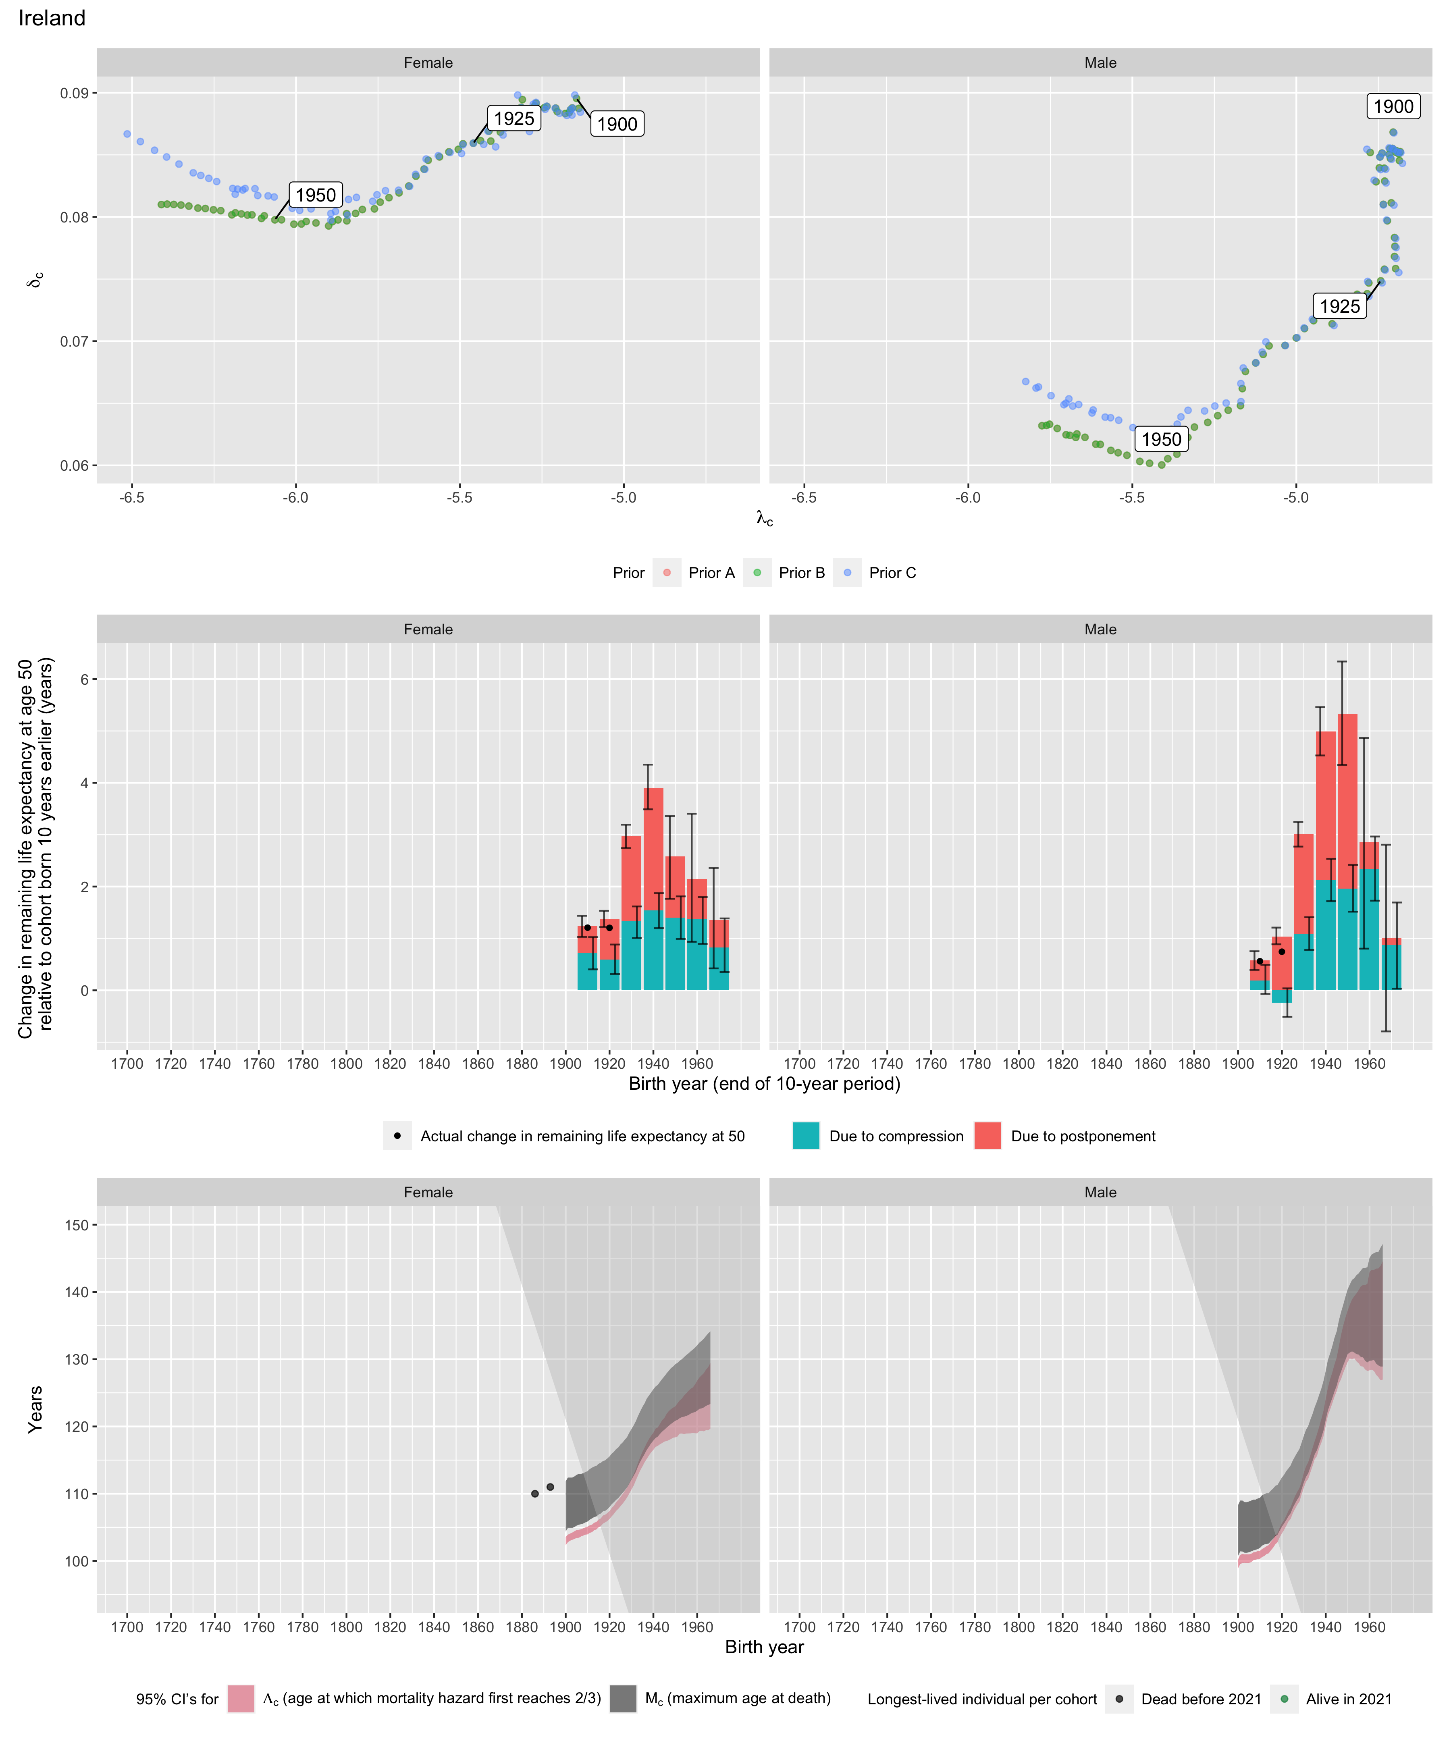
Longest-lived person in each cohort
Sex | Age | Cohort | Alive | Name | Birth date | Death date | Source
Female | 110 | 1886 | N | Mary Ellen Geaney | 1886-01-02 | 1996-04-05 | GRG
Female | 111 | 1893 | N | Margaret Dolan | 1893-08-30 | 2004-12-02 | GRG

